Department of Computer Science and Engineering
Lab Report
Lab Report No | : | 03
Lab Report Name | : | Quick Sort and Merge Sort
Course Title | : | Computer Algorithm and Complexity Sessional
Course Code | : | CSE 226
Name | : | Fahim Faisal Pathan
ID | : | 1119033
Level | : | 2 | Term | : | 2 | Section | : | A | Group | : | G2
Date of Submission | : | 20/05/2026 | Semester | : | Spring | Year | : | 2026

Marking Rubric
Problem Understanding & Report Clarity (3) | Implementation (4) | Results, Analysis & Presentation (3) | Total(10)

Key Learning:
• Uses the Divide and Conquer technique.
• Selects a pivot element for partitioning.
• Smaller elements move left of pivot.
• Larger elements move right of pivot.
• Recursive calls sort the subarrays efficiently.
• Divides the array into smaller halves.
• Uses recursion until single elements remain.
• Merges sorted halves step by step.
• Requires an extra temporary array.
• Provides stable and efficient sorting performance.

Code Input for Quick Sort:
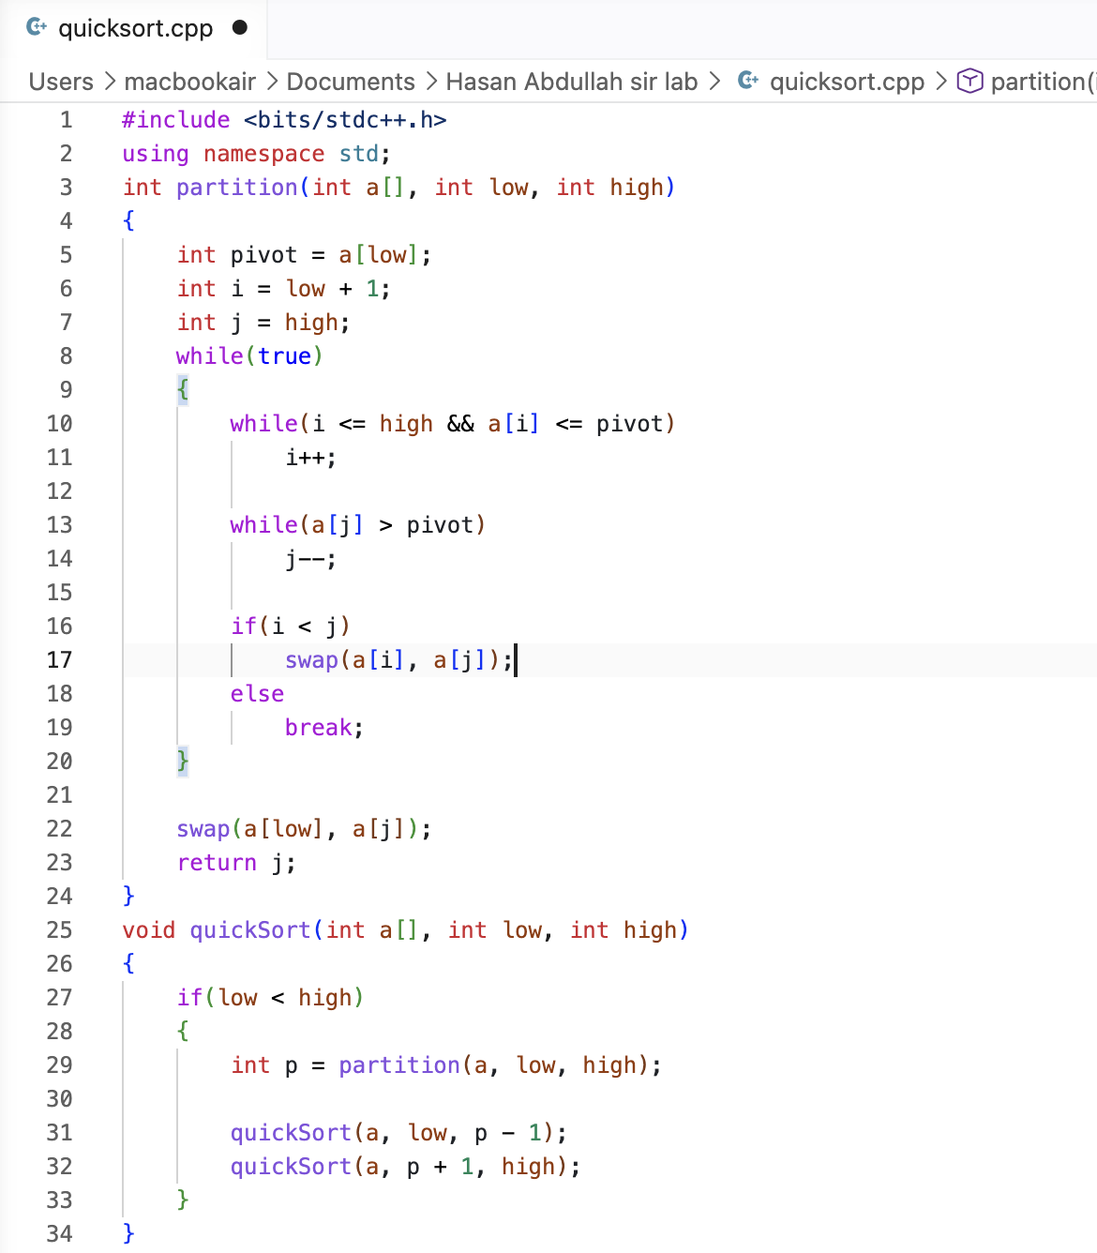

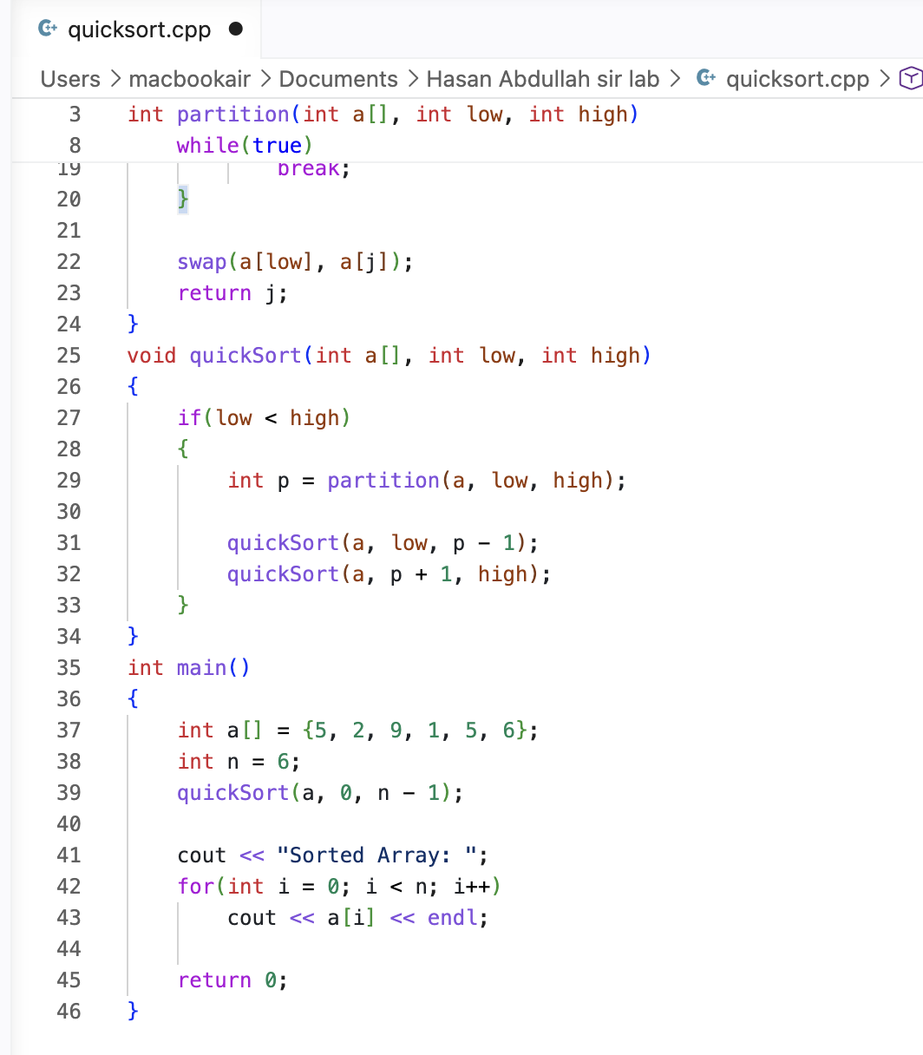

Code Output:
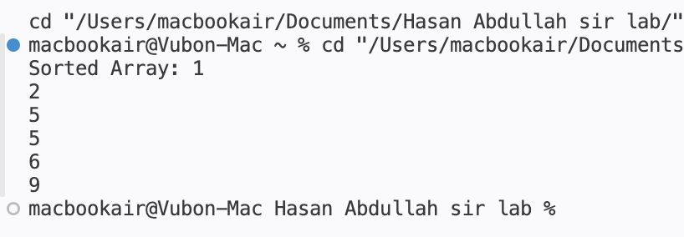

Code Input for Merge Sort: 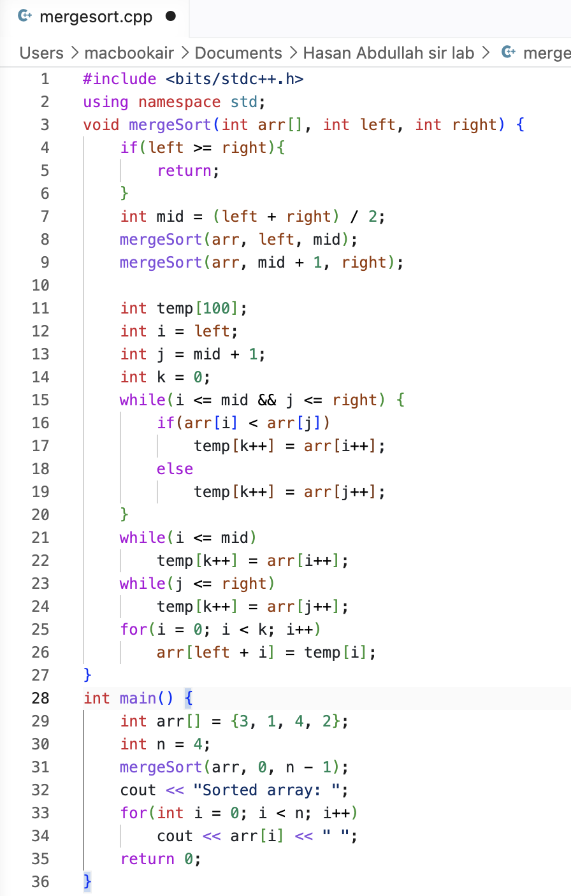

Code Output:

